GLEANINGS — June 29, A.D. 2014 Special Addition
Today’s gleaning is not a devotion or meditation, but the presentation of an opportunity. We anticipate that Pastor Benson Akello will be on hand today to share more about…
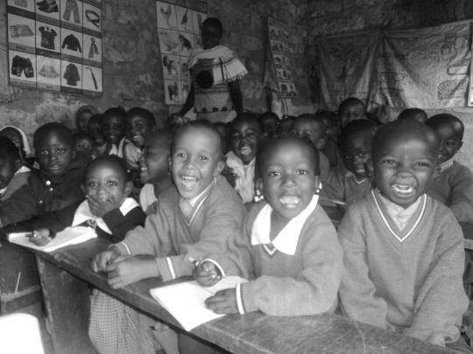
NEEDS AT JOY SCHOOL & CHURCH KENYA
MOST URGENT
Need of ½ ticket back to Kenya $1,200
Monthly budget for food and supplies $2,500
Need of plastering classrooms/church walls $3,000
Text books $2000
School Van $10,000
Stationeries & supplies $650
Equipped school library $5,000
(Books, shelves, tables, chalk boards, etc.)
Unfinished classrooms/church windows glasses $650
Computers for School children $3,000
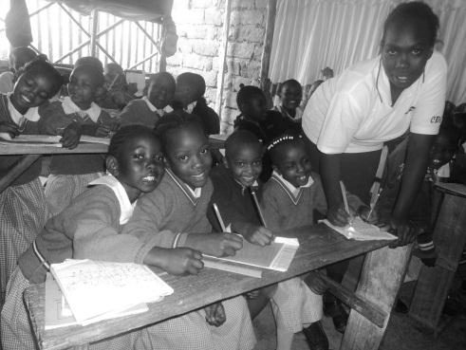
School Building (2-story) $25,000
Kitchen $1200
Washing machine $1000
Mattresses $500

SECONDARY NEEDS
School bicycle for the messenger $100
Additional school toilets $1000
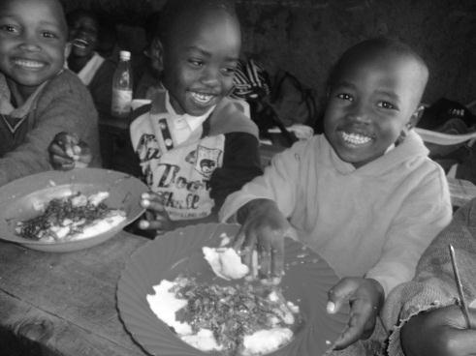
Additional desks for children $600
2 laptops for the Board and Head Teacher $1,000
20 sewing machines to train church women $2,500

VISION NEEDS
Additional field for playground and Expanding $15,000
To hire trained teachers $1,800 per teacher per year
(Currently 9 volunteer teachers in preschool through 5th grade)

How to give:
Cash and check (in person) * Electronic transfer * Credit Card using Pay Pal (web site)
Web site: www.joyreformedpresbyterianchurch.org
E-mail: revbensonakello@yahoo.com

